Final Project Report
Smart Car Redesign & Vision-Based Autonomous Navigation
Course: Artificial Intelligence Systems Engineering Design I
Instructor: Dr. Shaimaa Ali
Date: April 3rd, 2026
Group: Team 2
Team Member | Student Number
Evan Romano | 251327329
Joseph Toma | 251283541
Mohammed Alamen Qassab | 251285296

Problem Statement
The Freenove 4WD Smart Car is an educational robotics platform designed to help users explore embedded systems, sensing, and control. While functional out of the box, its default configuration presents several limitations when evaluated from a systems engineering perspective. These limitations effect efficiency, reliability, and the ability to scale toward more advanced autonomous behaviour.
The original platform includes four independently driven wheels, a servo-based gimbal mounted at the front of the chassis with an ultrasonic sensor and a camera co-mounted on it, and a line tracking sensor underneath the chassis. The four-motor drivetrain increases power consumption and complicates control without meaningfully improving manoeuvrability. The gimbal physically couples two components that have different optimal mounting positions, adds mechanical instability, and requires additional wiring and servo power. The electronics, including the Raspberry Pi, motor driver board, and wiring, are fully exposed on the top surface of the vehicle, making the system vulnerable to damage during operation.
From a software perspective, the default system relies on pre-programmed behaviours such as obstacle avoidance and line tracking that do not make use of modern computer vision techniques. The robot cannot interpret its environment in a meaningful way or adapt beyond simple reactive responses.
Figure 1 shows the base Freenove smart car configuration. The exposed electronics, servo-mounted camera, and four-wheel drive system highlight the sources of inefficiency and complexity that motivated this redesign.
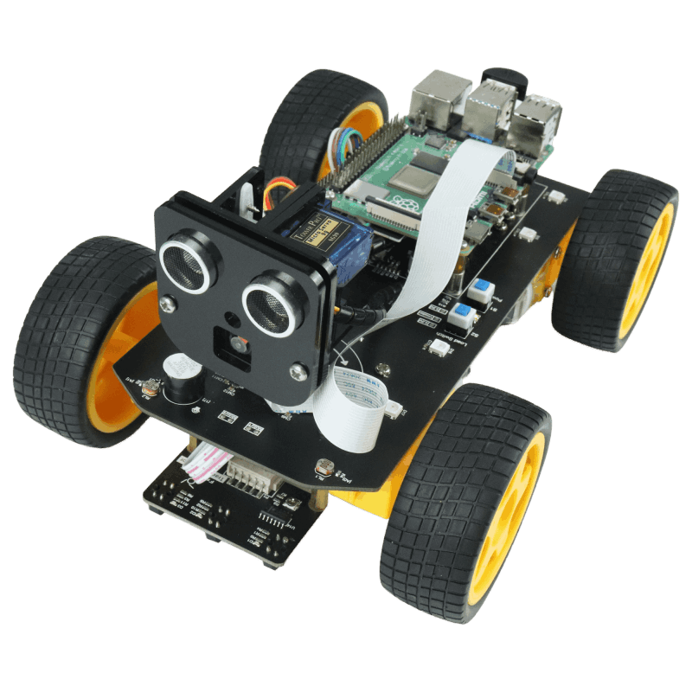
Figure 1: Original Freenove 4WD Smart Car showing exposed electronics, servo-mounted camera system, and four-motor drivetrain.
To address these issues, this project redesigns the platform with an emphasis on simplicity, efficiency, and autonomous capability. The drivetrain is reduced to front-wheel tank drive. The gimbal is eliminated entirely. The ultrasonic sensor is relocated to a fixed front-facing mount and serves as the sole obstacle detection mechanism. The camera is given a custom overhead mount that angles it downward toward the ground in front of the robot, providing a stable field of view for AprilTag detection. The chassis is adhered directly to the base board, removing the need for screw fasteners. On the software side, a target AprilTag is selected by the operator before the robot starts, and the robot navigates toward that tag while using the ultrasonic sensor to avoid obstacles along the way.

Requirements
The system requirements were developed based on the limitations identified in the original smart car platform and the objectives of the redesign. These requirements focus on improving system performance, reducing complexity, and enabling autonomous behaviour through sensor integration and control logic. To ensure clarity and traceability, the requirements are divided into functional and non-functional categories.

Functional Requirements
The robot must move forward autonomously without manual input under normal indoor operating conditions. The system must use the ultrasonic sensor to continuously measure the distance to objects in front of the robot. When a measurement falls below a defined safety threshold, the robot must stop and execute a turning manoeuvre before resuming forward motion.
The system must use the onboard camera to detect and decode AprilTag markers in real time. A target tag ID is specified by the operator before the robot is started. When that tag is identified in the camera frame, the system must extract its position and use that information to steer the robot toward the marker. All other tags must be ignored. The control system must integrate ultrasonic obstacle avoidance and vision-based tag navigation within a single continuous loop, with obstacle avoidance taking priority. The Raspberry Pi must be able to run custom Python scripts so that control logic can be modified and extended throughout development.

Non-Functional Requirements
The redesigned system must consume less power than the original four-wheel drive configuration by reducing the number of active motors from four to two and eliminating servo actuation. Wiring must be simplified relative to the original platform. Component layout should be organized to reduce the likelihood of disconnections during operation. The chassis must protect the Raspberry Pi and motor driver from external contact while remaining lightweight enough for mobile operation. All custom mechanical parts must be compatible with standard FDM 3D printing and designed to minimize print time and material usage. The software must be organized into modular components covering perception, state management, and motor control so that individual subsystems can be tested and updated independently. The camera must be mounted in a fixed position that provides a consistent downward-facing field of view suitable for AprilTag detection under typical indoor lighting without any active adjustment.

Design Constraints
In addition to the functional and non-functional requirements, several constraints influenced the design process. The system is limited to the hardware provided in the Freenove smart car kit, including the Raspberry Pi and motor driver board. All modifications must be compatible with these components.
The available power supply places a limit on the number of active components that can be used simultaneously. This constraint directly influenced the decision to remove redundant actuators and simplify the drivetrain.
Time constraints associated with the project schedule limited the extent of testing and iteration. As a result, design decisions prioritized reliability and manufacturability over experimental features. Manufacturing constraints also played a role in the final design. The available 3D printing resources required that all components be designed to minimize print time while maintaining structural integrity.

Design

System Overview
The redesigned system is built around the Raspberry Pi, which serves as the central processing unit and coordinates all sensing, decision-making, and actuation. The ultrasonic sensor feeds continuous distance data to the control loop for obstacle detection. The camera feeds image frames to the perception pipeline for AprilTag recognition and positional estimation. Based on the outputs of these two sensing sources, the control system determines the appropriate motor commands and sends them to the motor driver, which actuates the two front wheels. A high-level representation of this interaction between sensing, processing, and actuation is shown in Figure 2.
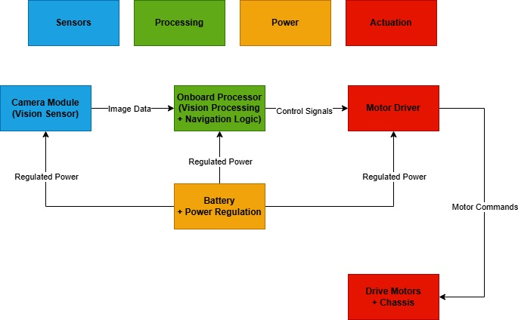
Figure 2: System architecture showing camera and ultrasonic inputs, processing pipeline, and motor control output.

Mechanical Design
The mechanical design of the system was significantly modified to address the inefficiencies and limitations of the original platform. The redesign focused on simplifying the drivetrain, improving structural integrity, and optimizing the system for manufacturability.

Drivetrain Redesign
The original four-wheel drive system was replaced with a front-wheel-driven tank drive configuration. This decision was based on the observation that four independent motors were not necessary for the intended operation of the robot. By removing the rear motors and wheels, the system reduces power consumption and simplifies motor control.
The front wheels are independently controlled, allowing the robot to perform turning maneuvers by varying the direction and speed of each wheel. This enables in-place rotation as well as gradual directional changes. To maintain stability after removing the rear wheels, a passive rear support mechanism was introduced. A standardized mounting solution was integrated to support the rear of the chassis while reducing design complexity and fabrication effort.

Chassis Design
A new chassis was designed in SolidWorks to improve both structural performance and manufacturability. The design reuses existing mounting points from the original platform, which simplifies integration with the provided hardware.
The chassis adopts an open-frame structure rather than a fully enclosed body. Material was removed in non-critical regions to reduce weight and printing time while maintaining structural strength in load-bearing areas. This optimization reduced the total print time from approximately 15 hours to 7 hours.
The redesigned chassis also provides improved protection for internal components. The Raspberry Pi, motor driver, and wiring are better contained within the frame, reducing exposure to external contact during operation. Figure 3 shows the final chassis design.
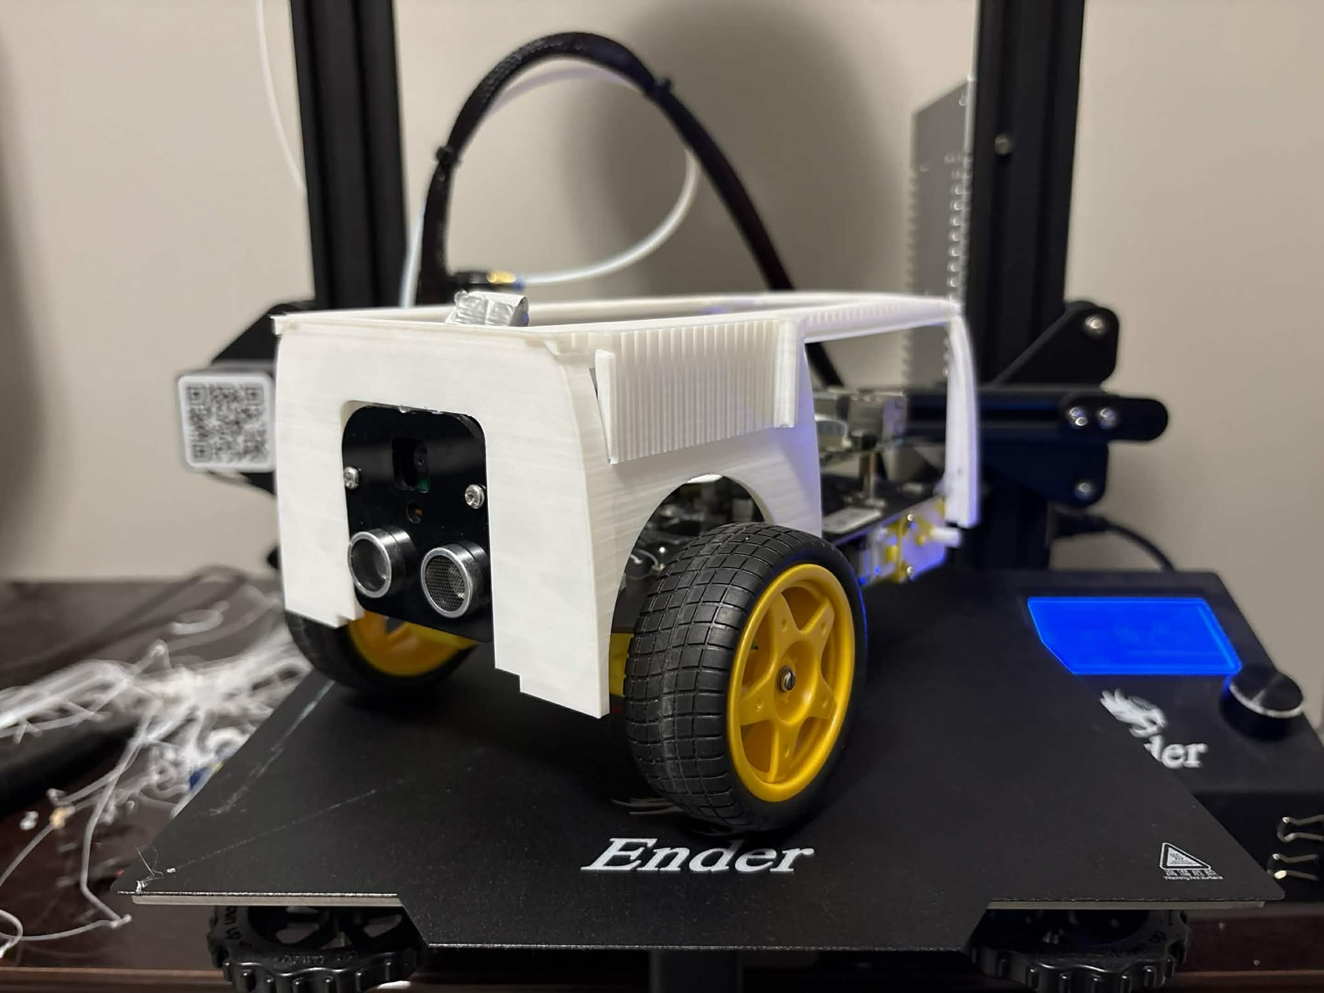
Figure 3: Redesigned chassis structure showing a lightweight frame and mounting features.

Sensor & Camera Mounts
The gimbal was removed and replaced with two separate fixed mounts, each optimized for its respective component. The ultrasonic sensor was given a dedicated mount at the front face of the chassis, positioning it to measure distances directly along the robot's forward axis. The camera was given a custom overhead mount: a vertical support rises from the rear of the chassis, and the camera is suspended forward from the top, angled downward toward the ground in front of the robot. This configuration, which draws a visual resemblance to the bioluminescent lure of a deep-sea anglerfish, provides a stable downward field of view for AprilTag detection. Separating the two components allowed each to be positioned for its specific function rather than forcing a compromise on the shared gimbal mount. Figure 3 illustrates the camera and ultrasonic mounts design and placement.
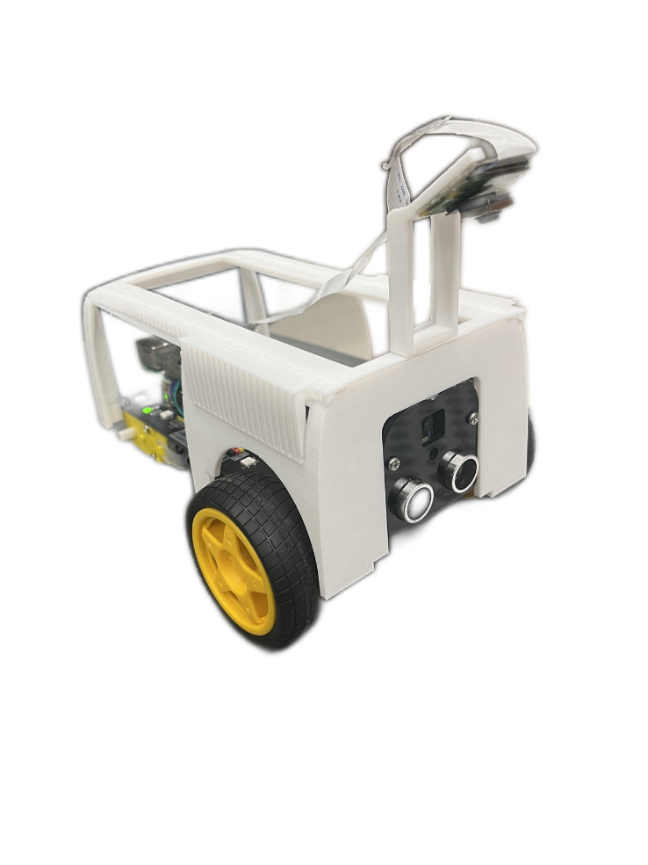
Figure 4: Fixed camera and ultrasonic mounts showing forward and downward orientation for improved field of view.

System Integration & Physical Layout
The placement of components on the robot was carefully considered to balance weight distribution, accessibility, and functionality. The camera is positioned toward the front of the robot to maximize its field of view. The Raspberry Pi and motor driver are centrally located to maintain balance and minimize wiring length.
The ultrasonic sensor is mounted at the front of the robot to provide direct distance measurements in the direction of motion. This placement ensures that obstacle detection aligns with the robot’s movement. Figures 5 and 6 show different views of the final assembled system.
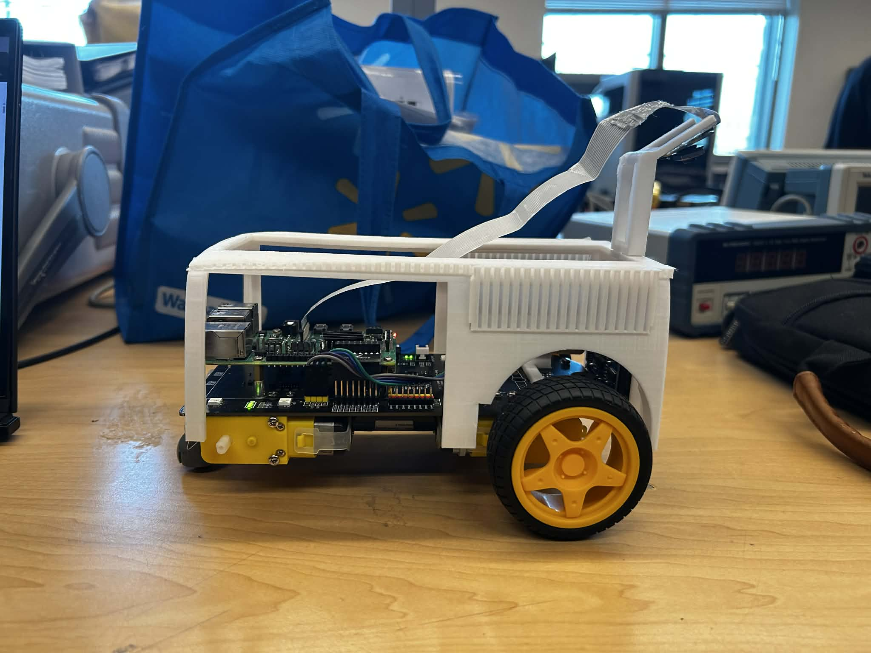
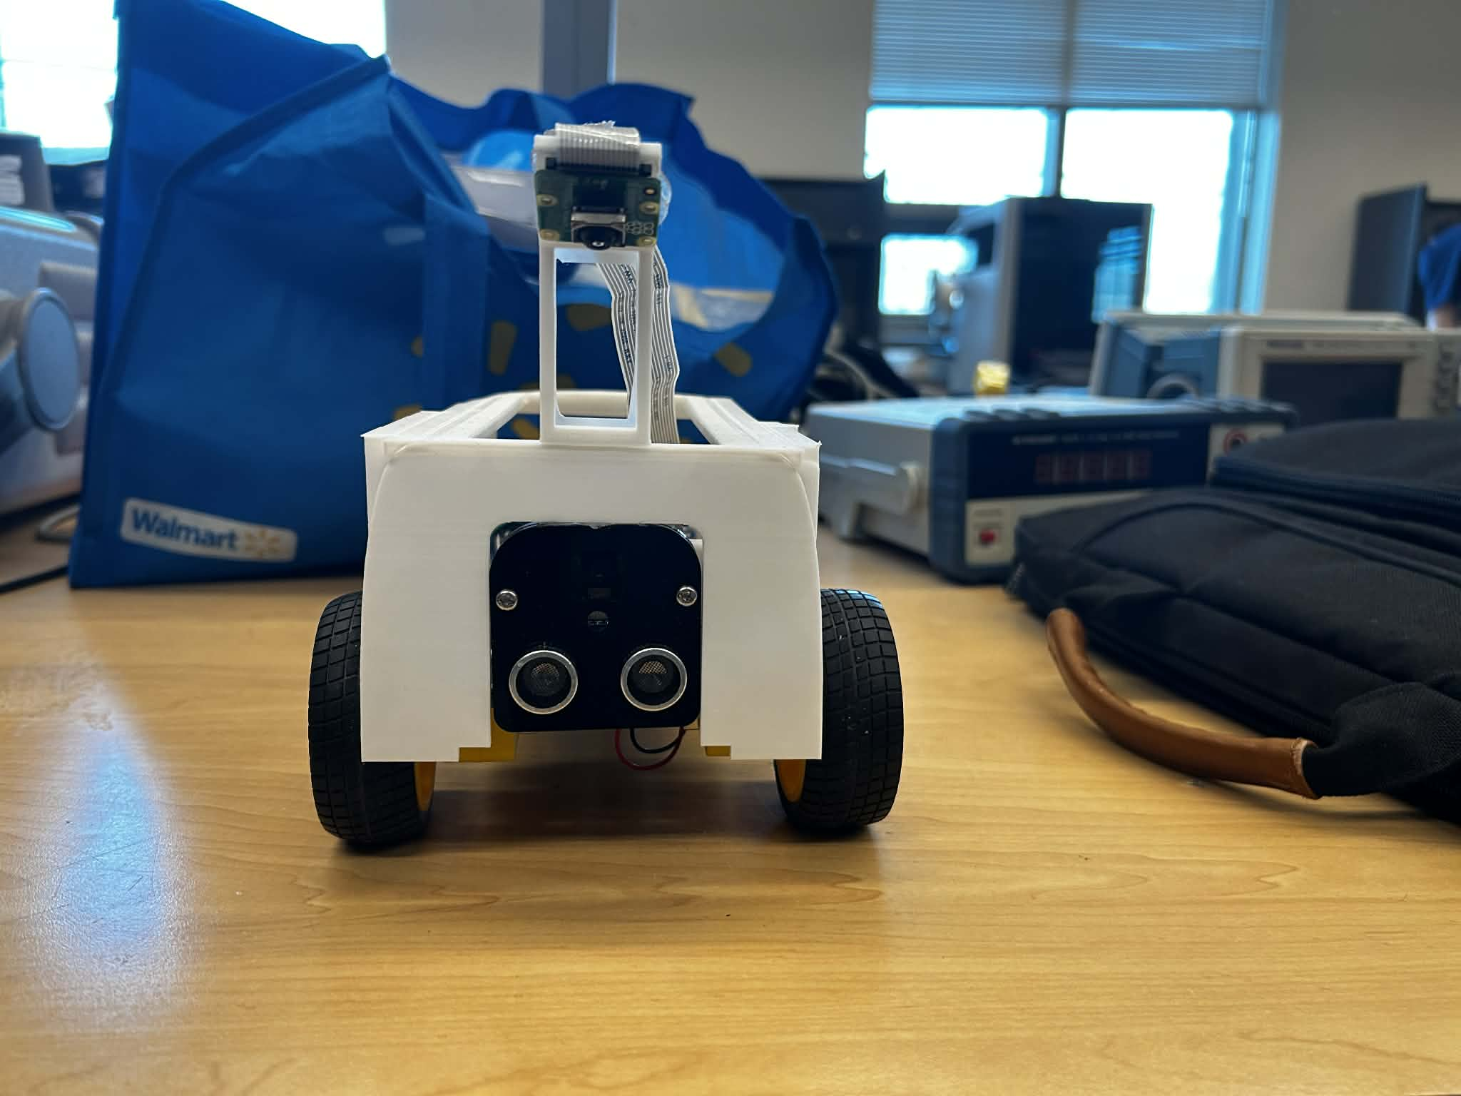
Figure 5: Front and side views of the assembled robot showing sensor placement and camera orientation.

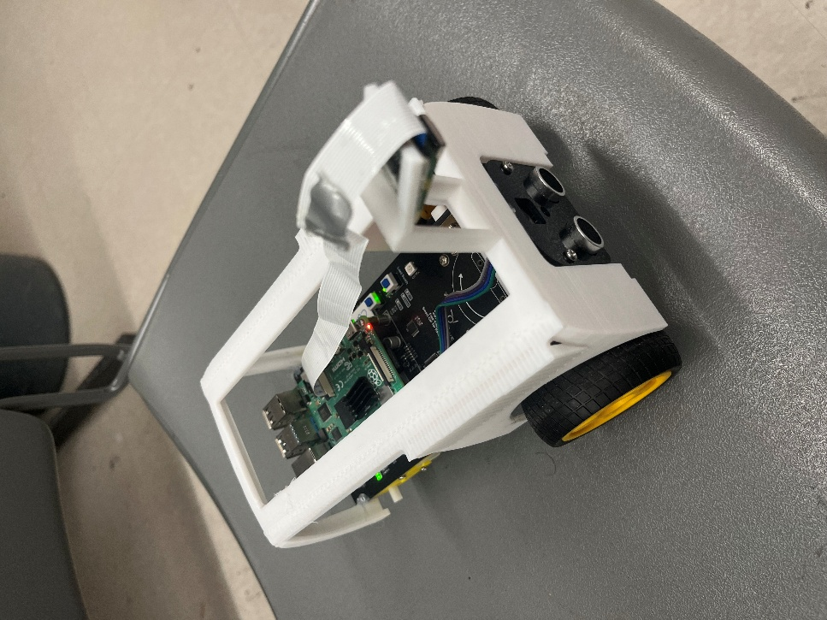
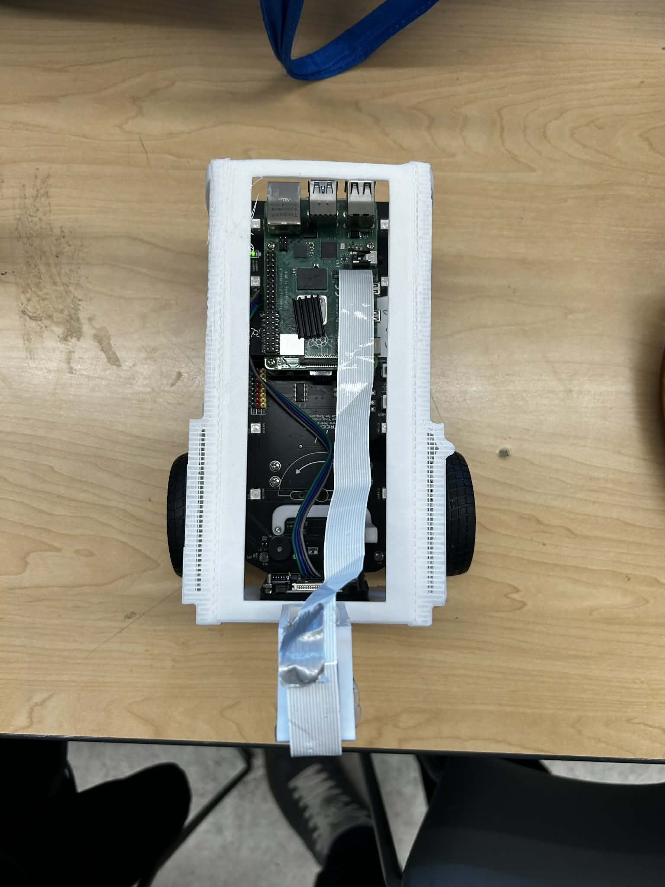
Figure 6: Isometric and top views of the assembled robot highlighting component layout and wiring organization.

Software Design
The software system was designed to enable autonomous behaviour through a combination of image processing, sensor integration, and state-based control.

Perception System
The ultrasonic sensor is polled every loop iteration using quick readings with median filtering to ignore noise. When the distance reaches below the required threshold, the robot immediately enteres the state of obstacle avoidance.
The camera captures frames at 640×480 and which then get converted to grayscale for optimal AprilTag detection using OpenCV libraries which has full 6 DOF pose estimation. The camera measures its distance and angle to a detected tag. Because each tag's physical position on the board is already known, the system works backwards from that measurement to calculate exactly where the robot is and which direction it's facing. When multiple tags are visible, results are then averaged for improved accuracy. The robot's facing direction is calculated using the sideways axis of the camera image, which provides reliable results, as the camera points straight down at the floor. In order to avoid errors, the system ignores heading readings that come from a single low quality tag detection or that suddenly jump by more than 90 degrees from the previous reading.

Control System
The control system has two main modes: navigation and obstacle avoidance, with obstacle avoidance always taking priority. When entered in navigation mode, the robot uses proportional differential steering. This is when both wheels drive forward continuously, with their relative speeds constantly being adjusted based on heading error, which is the difference between the direction the robot is currently facing and the direction it needs to face to reach the goal. Small errors produce subtle curves, while large errors are reacted to with one wheel to slow or stop for tighter turns. This avoids in place rotation, which was found to cause loss of tag visibility during the testing stage. When an obstacle is detected, the robot is programmed to stop and executes short, fast turn bursts, checking the sensor between each one until the path reads clear. It then drives past in short bursts of motion with sensor checks between each movement. If the sensor reads below 20 cm at any point, an emergency reverse is triggered immediately. After avoidance is complete and the path is clear, navigation is entered into naturally and steers the robot on course toward the goal. Before planning begins, multiple pose readings are averaged to reduce initial position noise. The program is also designed for when no tags are visible (the robot steers of course), it will reverse slowly to a position it can redetect them. A representation of this control logic is shown in Figure 6.
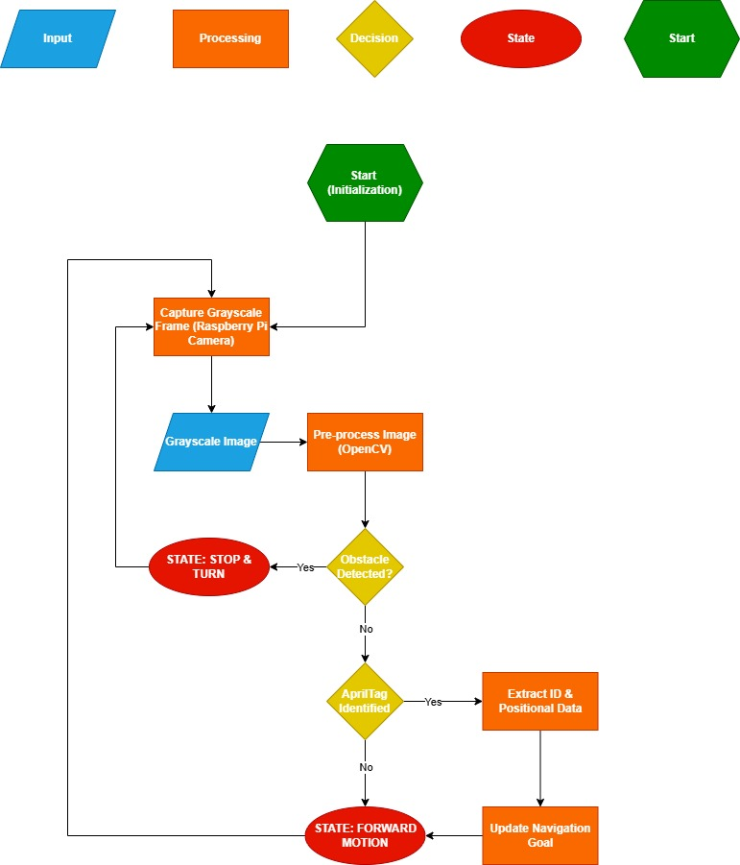
Figure 7: State-based control flow diagram showing transitions between forward, stop, and turning states.

Motor Control Implementation
Motor control is implemented using pulse-width modulation signals generated by the Raspberry Pi. The two front motors are controlled independently, allowing for differential drive behaviour. By varying the direction and speed of each motor, the robot can perform forward motion, turning, and in-place rotation. This approach provides sufficient maneuverability while keeping the control system simple.

Implementation
The implementation of the redesigned smart car involved both hardware modification and software development. This phase focused on translating the proposed design into a functional system while addressing practical challenges related to integration, compatibility, and performance.

Hardware Implementation
The hardware implementation began with modifying the original Freenove smart car platform. Several components were removed to simplify the system and align it with the redesigned architecture. These included the rear motors and wheels, the servo-based camera gimbal, and the line tracking module. Removing these components reduced power consumption and significantly simplified the wiring layout.
Following this, the redesigned mechanical components were prepared for fabrication. The chassis, camera mount, ultrasonic mount and rear support structures were modelled in SolidWorks and exported as STL files. These components were then manufactured using 3D printing. The chassis design was optimized before printing by introducing cutouts in non-critical regions, which reduced print time while maintaining structural integrity.
Once printed, the components were assembled onto the robot. The chassis was mounted using hot-melt adhesive (HMA), which ensured compatibility without requiring additional modifications. The anglerfish camera mount was installed at the rear of the frame with the camera suspended forward and angled downward. The ultrasonic sensor was fitted into its front-facing mount. The rear support was installed to stabilize the chassis after removal of the rear wheels. Electrical connections were then reconfigured to reflect the reduced number of components. Wiring was organized to minimize clutter and improve accessibility for debugging and maintenance. Figure 8 shows the fully assembled hardware system after integration.
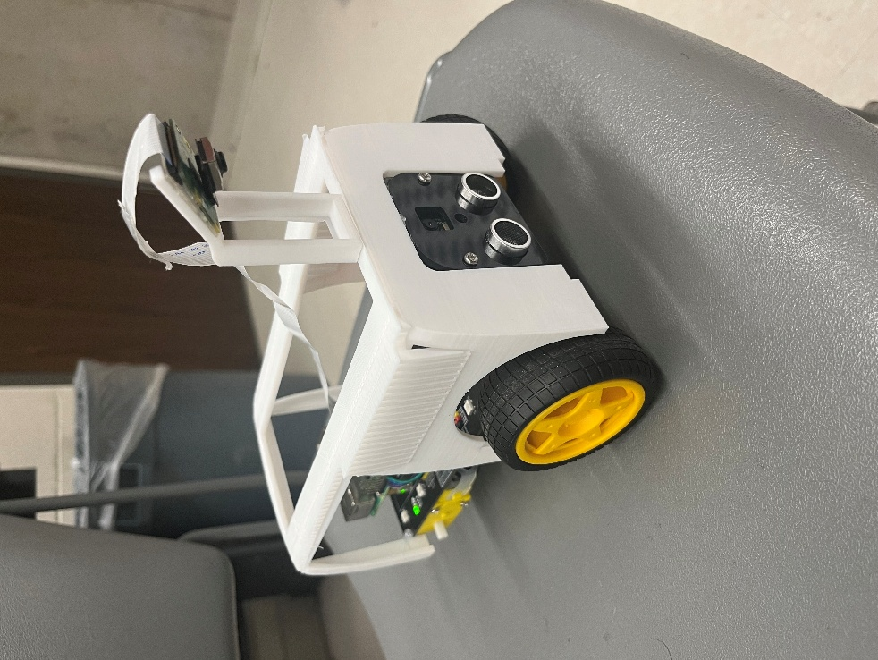
Figure 8: Final assembled robot showing redesigned chassis, camera mount, and simplified wiring layout.

Software Implementation
The software system was implemented in Python and deployed on the Raspberry Pi. Development began with establishing reliable communication with the robot through SSH, allowing code to be transferred and executed remotely.
The codebase was structured into modular components to separate perception, control, and hardware interaction. This modular approach improved readability and allowed individual subsystems to be developed and tested independently.
Image processing was implemented using the OpenCV library. The camera feed was captured and converted to grayscale to reduce computational load. This grayscale image was then used for AprilTag recognition. The AprilTag detection pipeline was integrated using existing OpenCV-compatible libraries, allowing the system to identify and decode tags within each frame.
Motor control was implemented using GPIO-based pulse width modulation signals. The control logic allowed independent control of the two front motors, enabling forward motion and differential turning. Functions were created to handle basic movements such as forward drive, stop, and turning maneuvers.
The control system was implemented as a state machine. Each state corresponded to a specific robot behaviour, including forward motion, stopping, and turning. Transitions between states were triggered by sensor input, including obstacle detection from the camera or ultrasonic sensor.

System Integration
System integration involved combining the hardware and software components into a single functional platform. This process required iterative testing and debugging to ensure that all subsystems operated together reliably.
The main integration challenge was coordinating the ultrasonic polling and camera processing within a single loop without introducing latency that would delay obstacle response. This was resolved by keeping the image processing pipeline lightweight and ensuring that the ultrasonic check always executes before the camera pipeline in each loop iteration. Motor startup behaviour was also tuned to ensure that the robot consistently overcame static friction when transitioning from a stopped state back to forward motion.
Another challenge involved tuning the obstacle detection behaviour. The system was designed to stop when an obstacle was detected and resume motion once the path was clear. However, it was observed that the robot could appear to stall if the motors did not immediately overcome static friction. This behaviour was addressed through adjustments in motor control signals and by refining the conditions required to transition between states.
Integration testing also confirmed that the tank drive configuration functioned correctly with only the front motors. The robot was able to perform both gradual turns and in-place rotations, validating the effectiveness of the simplified drivetrain design.

Repository and Version Control
All source code, configuration files, and supporting documentation are maintained in the project GitHub repository. Changes were committed regularly throughout development to track progress and allow rollback when needed.
GitHub Repository: https://github.com/ShaimaaAliECE/group-project-vision-control-systems-group.git

Testing
Testing was conducted in a structured and iterative manner to validate both individual subsystems and the fully integrated robot. The objective of testing was to ensure that the redesigned system met the functional requirements related to motion, obstacle detection, and AprilTag recognition, while also verifying mechanical stability and reliability under repeated operation.

Testing Strategy
The testing approach followed a bottom-up methodology, beginning with low-level component validation and progressing toward full system integration. This approach reduced debugging complexity and allowed issues to be isolated more effectively.
Initial testing focused on verifying hardware functionality and communication. This included confirming motor response to control signals, validating camera feed acquisition, and ensuring that all software scripts could be executed reliably on the Raspberry Pi. Once these baseline checks were complete, subsystem-level testing was performed on motion control, obstacle detection, and AprilTag detection independently. The final stage involved integrated system testing, where perception and control were combined to evaluate real-time autonomous behaviour.

Motion & Drive System Testing
Testing of the drive system was conducted after modifying the robot to operate using only the two front motors. The objective was to verify that the updated tank drive configuration provided sufficient mobility and control.
The robot was tested for forward motion, stopping behaviour, and turning capability. Forward motion tests confirmed that the robot could move consistently across different indoor surfaces. Turning tests validated that differential motor speeds applied to the front wheels allowed the robot to rotate effectively and change direction.
It was observed that the robot could perform in-place turning using opposing wheel motion, which confirmed correct implementation of the tank drive logic. Minor variations in motion were observed depending on surface friction, particularly on carpeted surfaces, where additional torque was required to initiate movement.

Obstacle Detection Testing
Obstacle detection was evaluated using the ultrasonic sensor. The goal of this testing phase was to confirm that the robot could reliably detect obstacles and respond appropriately. For ultrasonic testing, objects were positioned directly in front of the robot at known distances. The sensor readings were monitored to ensure accurate distance measurement. The system was configured with a safety threshold, and the robot was observed to stop when the measured distance fell below this threshold.

AprilTag Detection Testing
AprilTag detection was tested using printed markers placed within the robot’s environment. The objective was to evaluate detection accuracy, range, and robustness under varying conditions. Markers were positioned at different distances and orientations relative to the camera. The system successfully detected and identified tags within the effective range of the camera. Detection accuracy was highest when the tag was within the central field of view and under consistent lighting conditions.
Some limitations were observed when lighting conditions were poor or when the tag was viewed at extreme angles. Despite this, the system demonstrated reliable performance within the intended operating conditions.

Integrated System Testing
Integrated testing combined motion control, obstacle detection, and AprilTag detection into a single operational workflow. The robot was placed in a controlled indoor environment with obstacles and AprilTag markers.
During testing, the robot demonstrated the ability to move forward, detect obstacles, stop, and execute a turning manoeuvre to avoid collisions. When AprilTags were present, the system was able to detect them, process their position and perform full navigation toward the tags. The interaction between perception and control systems was validated, confirming that sensor inputs could successfully influence motor behaviour in real time.

Testing Limitations
While the testing process provided strong validation of system functionality, several limitations were identified. Testing was conducted primarily in indoor environments with controlled lighting, which does not fully represent real-world conditions. Additionally, time constraints limited the extent of long-duration and stress testing. Despite these limitations, the testing performed was sufficient to demonstrate that the system meets its primary functional requirements and provides a stable platform for further development.

Demonstration
The final system was demonstrated through a combination of recorded videos and in-person testing to validate the overall functionality of the redesigned smart car. The purpose of the demonstration was to show that the mechanical redesign, control system, and sensing components operate together as a complete system.
The completed system was demonstrated in a controlled indoor environment. A target AprilTag was selected before the run began. The robot started in the forward state and moved autonomously while the ultrasonic sensor monitored for obstacles, and the camera scanned for the target tag. When obstacles were encountered, the robot stopped and turned away before continuing. When the target tag entered the camera frame, the robot adjusted its heading and drove toward the marker. The demonstration confirmed that all primary functional requirements were met: autonomous forward motion, ultrasonic-based obstacle avoidance, and AprilTag-guided navigation all operated together within a single continuous control loop.
A live demonstration of the system is provided using the video links below. The demonstrations include forward motion, obstacle detection and avoidance, tank drive turning behaviour, and AprilTag detection.
Demonstration Video 1: https://uwoca.sharepoint.com/:v:/s/MechaTron/IQANUVOLZE2DTbNB4miZvS1NATx_gPIuCydbi1XaigMrfo0
Demonstration Video 2:
https://uwoca.sharepoint.com/:v:/s/MechaTron/IQB5pJSBiWamQ75Jfs9v6UGiAS2RF-7ECTSGE-Tq4rXhcF8
Demonstration Video 3: https://uwoca.sharepoint.com/:v:/s/MechaTron/IQDS1aCh5DRKQLb10CQ-VPY8AaOBaeDdtXQqy6jFgXjHeGw
Demonstration Video 4: https://uwoca.sharepoint.com/:v:/s/MechaTron/IQCt6mYFTTCyT7JdkqUR3sgIAd9NhOoxBFxyfh7LoLwSAcE
Demonstration Video 5: https://uwoca.sharepoint.com/:v:/s/MechaTron/IQBuphaJOmx4QofNCKMqidNgAU9SHLvqbGQ1YxyU_ENzk6M

Conclusion
This project focused on redesigning the Freenove 4WD Smart Car to improve its mechanical simplicity, power efficiency, and autonomous capabilities. The original system contained several unnecessary components and design limitations that reduced its effectiveness as a platform for intelligent robotics. Through a combination of mechanical redesign and software development, a more efficient and functional system was achieved.
The transition from a four-wheel drive configuration to a front-wheel tank drive system significantly reduced power consumption and simplified motor control. Removing the rear motors and replacing them with a passive support structure improved both efficiency and reliability while maintaining stability during motion. The redesigned chassis provided a more durable and lightweight frame that protects internal components and reduces manufacturing time. In addition, replacing the servo-based camera system with a fixed mount improved system stability and reduced wiring complexity.
On the software side, the implementation of vision-based sensing and control allowed the robot to operate autonomously within a controlled environment. The system is capable of forward motion, obstacle detection, and turning behaviour using onboard sensing and a state-based control structure. The integration of AprilTag detection further extends the system’s capabilities by enabling the identification of visual markers, which can be used for navigation and localization tasks.
Testing and demonstration results confirm that the redesigned system meets the primary objectives defined at the beginning of the project. The robot operates reliably under the tested conditions and demonstrates coordinated interaction between hardware and software components.
Overall, the project demonstrates the importance of thoughtful system-level design in mechatronics. By simplifying the mechanical structure and focusing on efficient sensing and control, the performance and usability of the platform were significantly improved. The final system represents a practical and scalable solution that can be further developed for more complex autonomous applications.

Future Work
The most significant improvement to the robot would be adding lateral sensing. The current ultrasonic sensor covers only a narrow forward cone field of view, limiting detection during turns or angled approaches. Adding sensors that face sideways or replacing the current sensor with one that covers a wider area, would let the robot detect objects that are not directly in front of it, preventing those side collisions.
The control architecture could also be improved by replacing fixed speed motor commands with proportional control. Steering corrections proportional to the tag's offset from the frame centre would produce smoother and more accurate navigation. Similarly, a proportional response to ultrasonic distance readings would allow the robot to slow down as it approaches obstacles rather than stopping abruptly.
Another improvement would be camera-based obstacle detection which could complement the ultrasonic sensor by extending detection range and allow for a distinction between object types. The navigation system could also be extended to support multi-waypoint routes, which enable the operator to choose a sequence of destinations for more advanced autonomous missions.
Finally, expanded testing across varied surfaces, lighting conditions, and longer continuous operation could be optimized to characterize real world performance and identify weaknesses not encountered in controlled environments.

